IGNITE
CHILDREN’S LEADER
Job Application Pack





Parish of Oswaldtwistle
Job Description

Job Title:  Salary:  Hours:  Location:  Employer:  Contract Type:  References:  Responsible to:  Pension:  Annual Leave:  Probationary Period:  Notice Period:  Expenses:  Right to work:  DBS:  Further training provided:  Work Equipment: | Ignite Children’s Leader  £26,000-£30,000 per annum  35 hours per week to be worked over 5 days.  Daily working pattern to be agreed on appointment. The post holder may be required to work additional hours to meet the reasonable requirements of the role but will be entitled to time off in lieu for anything beyond their normal working hours.  Within the churches of the Parish of Oswaldtwistle and the Parish Office, New Lane, Oswaldtwistle – ability to travel between sites will be needed. Some work from home as required.  The Parochial Church Council of the Parish of Oswaldtwistle  Permanent  Appointment will be subject to the receipt of two satisfactory references, ideally including present or most recent employer, and a faith reference.  The Vicar of Oswaldtwistle following appointment.  10% employer contribution; 3% employee contribution.  25 days per annum, plus statutory bank holidays to be arranged with the line manager. The holiday year runs from 1st January to 31st December.  The role will be subject to completion of a satisfactory 6-month probationary period, with the first review after 3 months. Appraisals will take place annually thereafter.  During the 6-month probationary period, 2 weeks’ notice is required by either party; thereafter 6 weeks’ notice is required.  HMRC standard rate travel allowance, plus other reasonable expenses  The post holder must have the right to reside and to work in the UK  A satisfactory enhanced DBS clearance is required.  This role comes with the opportunity for further training and obtaining qualifications with Emmanuel Theological College  Equipment specifically for work provided, including laptop and phone.

Background
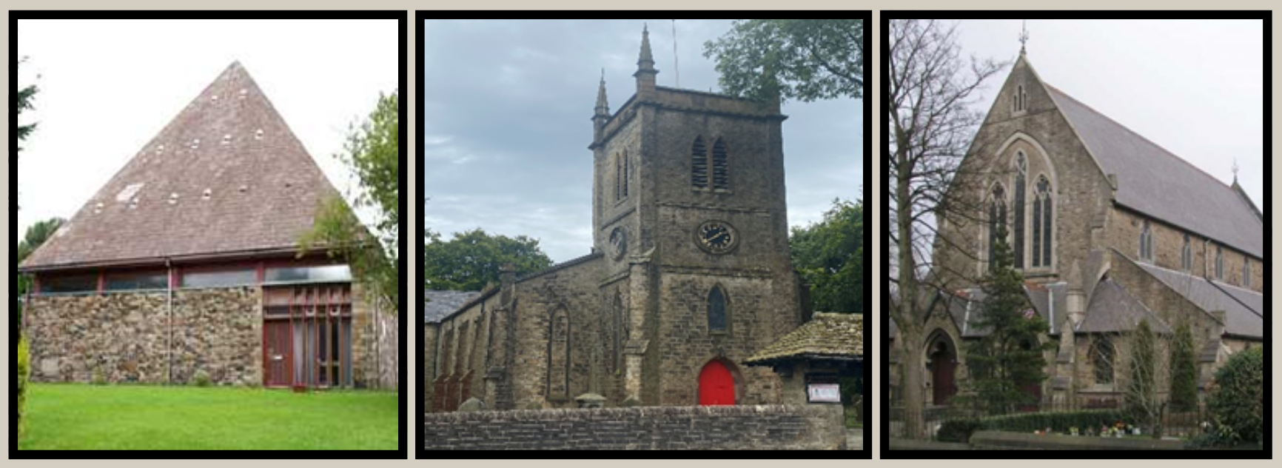

The Parish of Oswaldtwistle is part of the Diocese of Blackburn and comprises of three churches: All Saints’ is a modern building to the west of the town, Immanuel is the oldest church and is situated to the south of the town, and St Paul’s is towards the centre of the town, but at the edge of the Parish.

We have a small Sunday school provision in two of our churches as well as recently beginning a junior choir. The parish has a puppet ministry for older children as well as a monthly youth group for children aged 8 and upwards.

There are several schools within the parish, and the church has strong relationships with both of our church schools, St Andrews and St Pauls, meaning there is much potential within Oswaldtwistle. Several uniformed organisations engage with the church too.

Purpose of the role

We have a vision to be a welcoming parish for all ages, looking out to the community. The purpose of this role would be to share the love and good news of Jesus with the children of Oswaldtwistle. We are looking for someone to take a collaborative leadership role in developing and overseeing the children’s ministry work within the parish.

Overview of the Main Aims and Responsibilities

Main Aims

- To work with each of the three churches overseeing and growing teams to develop Sunday morning provision for children.
- To develop and lead a group for parents and toddlers, and an afterschool provision for primary aged children, helping our children grow both in numbers and discipleship.
- To work in collaboration with clergy and school staff in developing work in our local church and state schools.
- To assist and develop seasonal work – such as Christmas and Easter services and socials, holiday clubs and more.

Responsibilities

- To work with each of the three churches overseeing and growing teams to develop Sunday morning provision for children.

- Collaborate with clergy and work alongside existing children’s workers to manage a team of volunteers to provide teaching during Sunday services; build relationships with families, create rotas, and offer or signpost to training as needed.
- To grow our numbers on a Sunday morning.
- Build relationships with parents and children attending the churches, helping them to grow in their relationship with Jesus; to identify those who might be ready for baptism or confirmation

- To develop and lead a group for parents and toddlers, and an afterschool provision for primary aged children, helping our children grow both in numbers and discipleship.

- Collaborate with clergy to create a new group for both parents and toddlers that will build relationships between them and church.
- Collaborate with clergy and school to create a new after school provision for primary school children that will help children to grow in faith.
- To build and oversee a team in order to support and develop this work.

- To work in collaboration with clergy and school staff in developing work in our local church and state schools.

- To enhance and expand upon relationships with staff, children and parents in both church schools and in state schools.
- In collaboration with clergy and the school to begin a new jointly agreed provision that best serves the children e.g. an after school or lunch club, a forest or eco-club.

- To assist and develop seasonal work – such as Christmas and Easter services and socials, holiday clubs and more.

- To assist with the church worship activities during the busy seasons of Christmas and Easter such as the nativity, Christingle, etc.
- To identify key opportunities throughout the year that would engage children and develop at least one e.g. a Light Party.
- To provide at least one holiday club provision throughout the year and lead a team to carry out this work.

In addition, the candidate will also be responsible for:

- Attending and contributing to team meetings, Ignite meetings, supervision meetings and PCC meetings as required.
- Setting a culture of encouragement for children in the parish.
- Working in collaboration with the PSO and clergy, ensuring that children are effectively safeguarded.

Given the nature and context of the work, it is an occupational requirement that the post holder should be a communicant member of the Church of England or a full member of a church within Churches Together in Britain and Ireland, in order to fulfil the main purpose of the post. This post is therefore exempt under Schedule 9 of the Equality Act.

Person Specification

Criteria |  |  | Criteria Assessed by
 |  |  | Application | Interview | Reference
a | A passionate and committed Christian enthusiastic for the gospel and the mission of the church | Essential | ✓ | ✓ | ✓
b | A good level of education – 5 GCSEs at A*-C (or equivalent) including Maths and English; one A level or equivalent | Essential | ✓
c | Someone excited and enthusiastic about discipling young children | Essential | ✓ | ✓ | ✓
d | Evidence of engagement with children/young people in a leadership role | Essential | ✓ | ✓ | ✓
e | Ability to work collaboratively as part of a team with a diverse group of people | Essential | ✓ | ✓
f | Teachable heart and willing to learn | Essential | ✓ | ✓
g | A commitment to safeguarding children and vulnerable adults, and ensuring the application of the Church of England safeguarding policy. | Essential | ✓ | ✓
h | Comfortable using Microsoft office and has an awareness of social media platforms | Desirable | ✓
i | A full UK drivers’ licence | Desirable | ✓
j | Well-organised and administratively effective, with the ability to manage own workload | Essential |  | ✓
k | Qualification in theology or willing to undertake theological training with Emmanuel Theological College. | Essential | ✓
l | An excellent communicator who is comfortable dealing with a wide range of people in a professional and friendly manner. | Essential | ✓ | ✓ | ✓

Safeguarding
The Parish of Oswaldtwistle is committed to safeguarding and promoting the welfare of children, young people and vulnerable adults. All post holders and volunteers are expected to share this commitment and undertake the necessary Diocesan Safeguarding Courses.

Diversity
The Diocese of Blackburn believes that diversity enables us to thrive and develop and is committed to race equality, welcoming applications from UK Minority Ethnic/ Global Majority Heritage backgrounds.

How to apply

Please complete an application form and send to Rev Barbara Hunter: vicar.parishofossy@gmail.com

Deadline for applications: Friday 26th June 2026
Interviews: 10th July 2026

For further information or an informal chat about the role, please contact Rev Barbara (vicar.parishofossy@gmail.com or ring 01254 223302)

